Project Title | Real Estate Investment Advisor: Predicting Property Profitability & Future Value
Skills take away From This Project | Python, Machine Learning, EDA, Data Analysis, Feature Engineering, Regression, Classification, Streamlit, MLflow, Model Evaluation, Feature Scaling, Domain Understanding.
Domain | Real Estate / Investment / Financial Analytics
Problem Statement
Develop a machine learning application to assist potential investors in making real estate decisions. The system should:
- Classify whether a property is a "Good Investment" (Classification).
- Predict the estimated property price after 5 years (Regression).
Use the provided dataset to preprocess and analyze the data, engineer relevant features, and deploy a user-interactive application using Streamlit that provides investment recommendations and price forecasts. MLflow will be used for experiment tracking.

Business Use Cases
✅ Empower real estate investors with intelligent tools to assess long-term returns.
✅ Support buyers in choosing high-return properties in developing areas.
✅ Help real estate companies automate investment analysis for listings.
✅ Improve customer trust in real estate platforms with data-backed predictions.

Approach

🔹 Step 1: Data Preprocessing
- Handle missing values and duplicates.
- Normalize or scale numerical features.
- Encode categorical features like Location and Property_Type.
- Create new features like Price per Sqft, School Density Score, etc.
- Create a binary label "Good Investment" based on domain rules (e.g., appreciation rate > threshold).

🔹 Step 2: Exploratory Data Analysis (EDA)
- Price trends by city
- Correlation between area and investment return
- Impact of crime rate on good investment classification
- Relationship between infrastructure score and resale value

🔹 Step 5: Streamlit App
- A user-friendly form for entering property details, filtering out properties by area, price, BHK etc.
- Show:
  - Classification: “Is this a Good Investment?”
  - Regression: “Estimated Price after 5 Years”
- Add visual insights (e.g., location-wise heatmaps, trend charts)
- Show model confidence scores & feature importance

Data Flow and Architecture
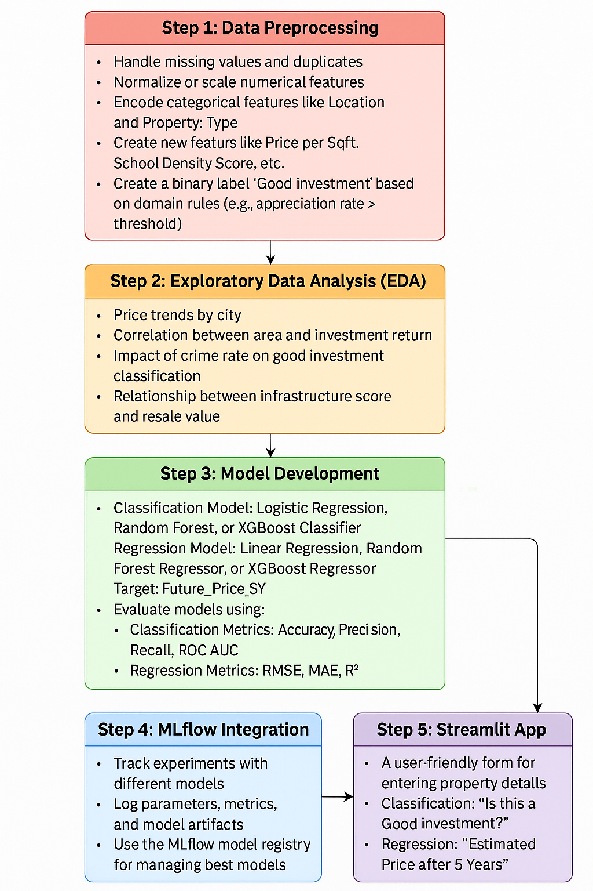
Target variables:

🔹Regression: Future Price (5 yrs)
Goal: Predict property price in 5 years.
- Fixed Rate: Future = Current * (1 + r)^t (e.g., r=8%)
- By Location/Type: Use different growth rates per city/property.
- Feature-based: Predict growth using property features (BHK, sqft, RERA, etc.)

🔹Classification: Good Investment
Goal: Decide if property is worth buying.
- Price vs Median: Price ≤ median → good investment
- Price per Sq Ft: Cheaper than median → good
- Multi-factor Score: Combine features (BHK≥3, RERA, ready-to-move) → threshold = good

Dataset
Data set link : india_housing_prices.csv
Dataset Description

Feature | Description
ID | Unique identifier for each property record
State | State where the property is located
City | City of the property
Locality | Specific neighborhood or locality
Property_Type | Type of property (Apartment, Villa, House, etc.)
BHK | Number of bedrooms, hall, kitchen
Size_in_SqFt | Area of the property in square feet
Price_in_Lakhs | Price of the property in lakhs (local currency)
Price_per_SqFt | Price divided by area; normalized price metric
Year_Built | Year when the property was constructed
Furnished_Status | Furnishing level (Unfurnished, Semi, Fully)
Floor_No | Floor number of the property
Total_Floors | Total number of floors in the building
Age_of_Property | Age of the property (Current Year - Year_Built)
Nearby_Schools | Number or rating of nearby schools
Nearby_Hospitals | Number of nearby hospitals
Public_Transport_Accessibility | Access to buses/metro/train
Parking_Space | Number of parking spots available
Security | Security features (Gated, CCTV, Guard)
Amenities | Amenities available (Gym, Pool, Clubhouse)
Facing | Direction the property faces (North, South, etc.)
Owner_Type | Owner type (Individual, Builder, Agent)
Availability_Status | Current status (Available, Under Construction, Sold)

Exploratory Data Analysis (EDA)

1–5: Price & Size Analysis
- What is the distribution of property prices?
- What is the distribution of property sizes?
- How does price per sq ft vary by property type?
- Is there a relationship between property size and price?
- Are there any outliers in price per sq ft or property size?
6–10: Location-based Analysis
- What is the average price per sq ft by state?
- What is the average property price by city?
- What is the median age of properties by locality?
- How is BHK distributed across cities?
- What are the price trends for the top 5 most expensive localities?
11–15: Feature Relationship & Correlation
- How are numeric features correlated with each other?
- How do nearby schools relate to price per sq ft?
- How do nearby hospitals relate to price per sq ft?
- How does price vary by furnished status?
- How does price per sq ft vary by property facing direction?

16–20: Investment / Amenities / Ownership Analysis
- How many properties belong to each owner type?
- How many properties are available under each availability status?
- Does parking space affect property price?
- How do amenities affect price per sq ft?
- How does public transport accessibility relate to price per sq ft or investment potential?
Results
- Cleaned and analyzed real estate dataset.
- Trained classification model with high accuracy for investment prediction.
- Regression model with low RMSE for price forecasting.
- Streamlit dashboard deployed with user input form and visual results.
- MLflow integrated to manage model tracking and performance comparison.

Project Evaluation Metrics
- Data Handling: Imputation, encoding, and outlier detection.
- Model Evaluation:
  - Classification: Accuracy, F1-score, Confusion Matrix
  - Regression: RMSE, MAE, R²
- Deployment: Functional Streamlit UI for predictions and analytics.
- Experimentation: Version-controlled and logged using MLflow.

Technical Tags:
Python, Pandas, Scikit-learn, XGBoost, Regression, Classification, Streamlit, MLflow, Real Estate Analytics, Data Visualization

Deliverables:
- Cleaned & processed dataset (CSV or SQL)
- Python scripts for EDA, model training, and evaluation
- MLflow experiment logs + registered models
- Streamlit application (with prediction + insights)
- Project documentation (Methodology, Findings, Use Cases)

Timeline:
Refer to your Zen portal or email for deadlines.
References:

Project Live Evaluation Metrics | Project Live Evaluation
EDA Guide | Exploratory Data Analysis (EDA) Guide
Capstone Explanation Guideline | Capstone Explanation Guideline
GitHub Reference | How to Use GitHub.pptx
Streamlit recordings (English) | Special session for STREAMLIT(11/08/2024)
Streamlit recordings (Tamil)
Streamlit documentation | Install Streamlit
Streamlit deployment document | Streamlit App on Streamlit Cloud
Mlflow documentation | An Introduction to MLflow Tracking, Managing, and Registering Machine Learning Models.pdf
Mlflow recordings | Day 1 :  Time to Learn - 2024_12_24 10_28 GMT+05_30 - Recording.mp4  Day 2:  Time to Learn - 2024_12_23 10_28 GMT+05_30 - Recording.mp4
Project Orientation (English) | POS : Real Estate Investment Advisor: Predicting Property Profitability & Future Value
Project Orientation (Tamil)

